do .. while:
∙ It is an exit control loop. i.e. in a do while the condition is tested at last. ∙ Here do , while are the keywords. ∙ It is also used to repeat a program several times based on a condition. ∙ In a do while, do block statements are executed first and later while condition is tested. If the while condition is true then once again the do block statements are repeated. Like this the process is continued until the while condition becomes false.
∙ In do while, the while should be end with semicolon ( ; ) .
∙ Regardless of while condition, the do statements are executed at least one
time. Due to this sometimes we are getting unwanted results [ garbage values ].
∙ Use do while whenever it is compulsory because of in do while the program is controlled at the bottom / last.
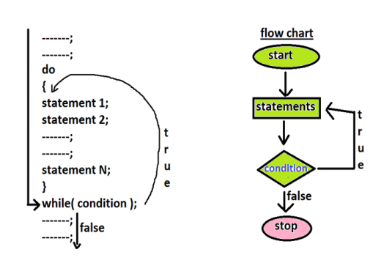
Finding no of digits in given no.
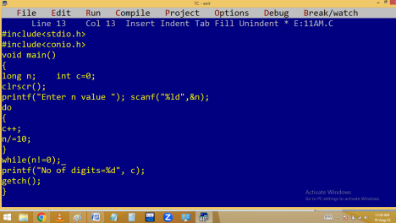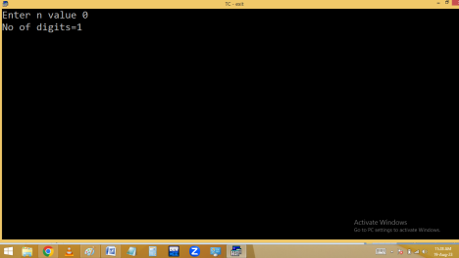
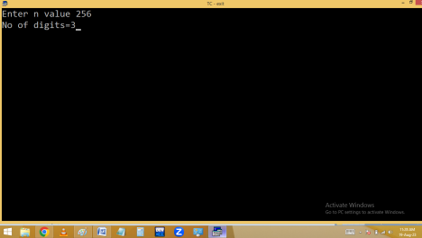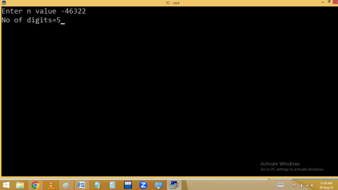
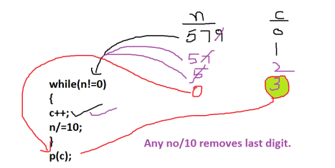Without using loop:
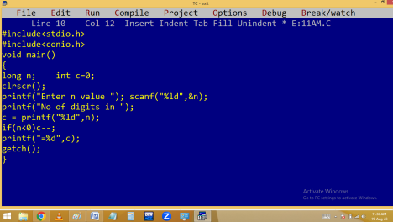
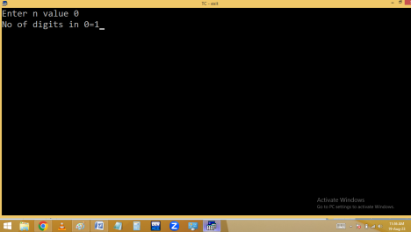
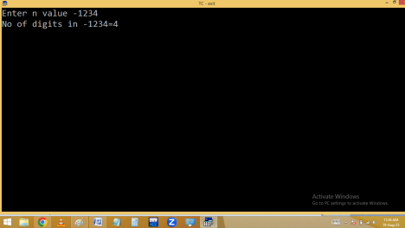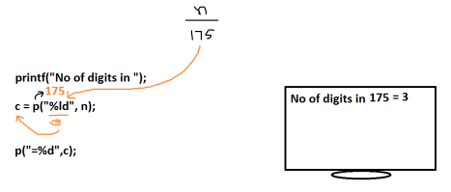Finding digits sum.
Eg: 123 🡺 1+2+3=6
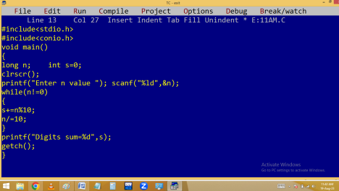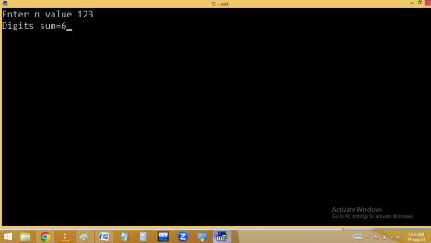
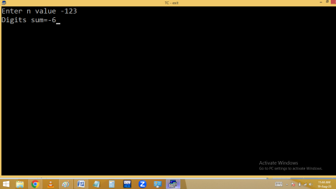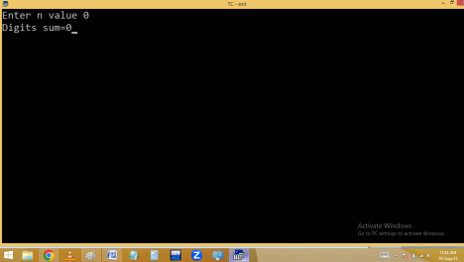
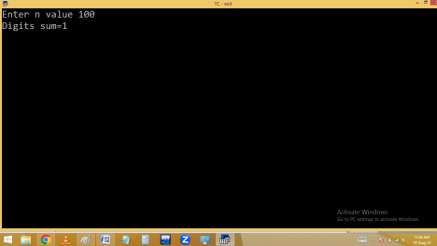Printing first and last digit of given no.
2048 🡺 2 first digit, 8 last digit.
Finding max and min digits of given no. Eg: 29108 🡺 9 max, 0 min
Eg. Reverse no
Printing 100 as 001:
Finding palindrome:
101 reverse 101
Home work: 102 🡺 One Zero Two

